East Sussex Social Value Marketplace User Manual

This Website is Managed by East Sussex County Council
Please ensure you also read our Terms and Privacy Policy.
If you would like to report an issue with this document please email the Administrator: socialvalue@eastsussex.gov.uk

Contents

- Introduction Page 3
- Register to use the Marketplace Pages 4 – 6

- Creating your organisation’s profile Pages 7 – 11

- Posting an offer of help or request for help Pages 12 – 17

- Responding to requests and offers Pages 18 – 20

- Giving and receiving feedback Pages 21 – 23

- The ‘About’ page Page 24

- The ‘Account’ page Pages 25 – 27

- Link to Supply to East Sussex Page 28

- Link to Crowdfund East Sussex Page 29

- Contact the Marketplace Administrator Page 30

- Introduction
Welcome to the East Sussex (ES) Social Value Marketplace. The ES Social Value Marketplace is co-designed by public, private and social sector organisations that are based in or deliver services within the county. This guide has been developed to outline how you can use the (ES) Social Value Marketplace to support our local communities.ES

Vision
Our vision is for the public, private and social sectors in East Sussex to work together so we can combine our efforts and resources and collectively use these to improve the social, economic and environmental wellbeing of our residents and local communities.

Why was the ES Social Value Marketplace created?
The ES Social Value Marketplace was created to help us achieve our vision by:
- Enabling the sharing of resources for the benefit of our residents and local communities
- Organisations working in local communities can request support and resources based on the real needs of residents in a local area
- Organisations that want to help can understand what communities need, where they need it and when they need it

- Encouraging partnership working and collaboration across the public, private and social sectors
- Organisations can create a profile and provide information about the services they provide
- Organisations can connect, communicate with and support each other if they are working towards a common social, economic or environmental outcome

- Securing additional value from public sector spending through the Public Services Social Value Act (2012)
- Public sector organisations in ES can use the ES Social Value Marketplace to comply with legislation and target the social value commitments secured through their procurement process towards local community needs
- Suppliers can use the ES Social Value Marketplace to identify local need that is within their capacity and capability to deliver and include them as part of their social value commitment when submitting bids for contracts

- Register to Use the ES Social Value Marketplace

  - To use the ES Social Value Marketplace you must register your organisation. Before registering you must review the Terms of Use and Privacy Policy. To view the terms and conditions of use you can:
- Click “About” on the main task bar at the top of the page
- Click “Support”
- Click “Terms and Conditions of Use”
(See picture below)
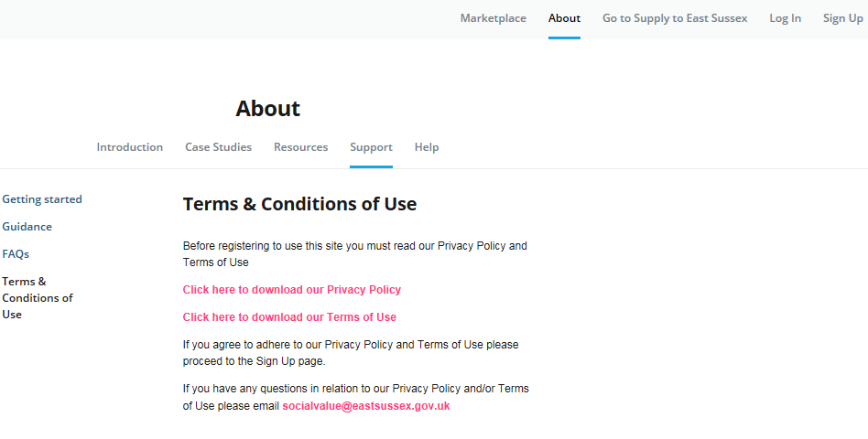
  - If you are willing to adhere to the terms and conditions of use you can continue with the registration process.
- Click “Sign Up” on the main task bar at the top of the page
- Type in the required information
- Organisation Name (Please enter the correct and full name of your organisation)
- Your first name and surname
- Organisation email address or your contact email if you have been nominated to represent your organisation. Please note this is the email address others will use to contact you.
- Create and confirm your password. (Please ensure you use a password that is not known to any other individual)
- Tick the box to confirm you agree to the Terms of Use and Privacy Policy

(See picture below)
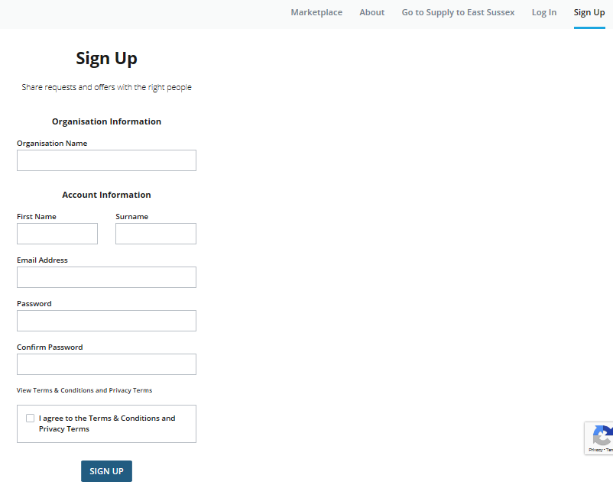

  - To avoid duplication only one profile should be set up for each organisation, however there can be multiple user accounts attached to the organisation profile.

- If you are the person setting up the account you will be regarded as the ‘primary user’. As the primary user you will be able to invite other team members from your organisation to join the ES Social Value Marketplace once your account has been approved.

- If someone in your organisation has set up an account, when you join the ES Social Value Marketplace and enter your organisations name you will receive a message stating that “an organisation with that name already exists”, and you will be given the option to join that organisation as a secondary user.

(See picture below)

  - When you click “Sign Up” you will receive confirmation that your account has been created. Your account will need to be approved by the administrator and you will be notified by email when this has been completed.

(See picture below)

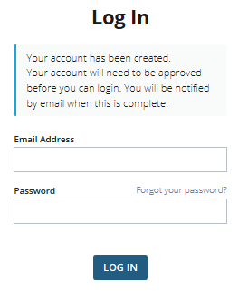

Please ensure you allow a minimum of 72 hours for this process.

- Creating your Organisation Profile

  - When your account has been approved you will receive an email informing you that you can log in and access your account

(See picture below)
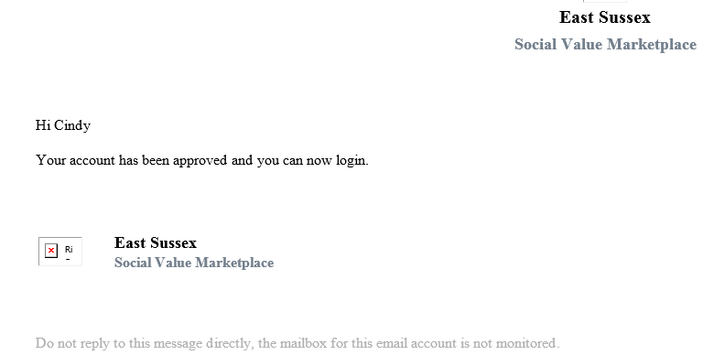

  - Click the link in the email or enter the following address in your browser https://socialvalue.supplytoeastsussex.co.uk/about/

  - Click “Log In” at the top of the page on the main task bar and enter your email and password. You can reset your password at any time by clicking “forgot your password?”

(See picture below)
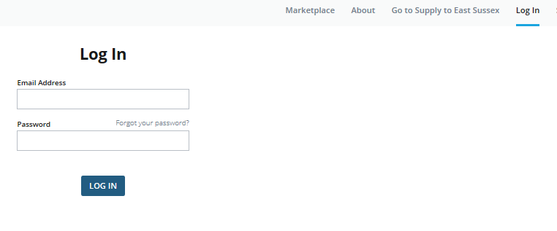

  - When you log in for the first time you will see a message on the top of the page informing you that you need to complete the key information in your organisation’s profile before your organisation will appear on the “Organisations” page of the Marketplace.

(See picture below)
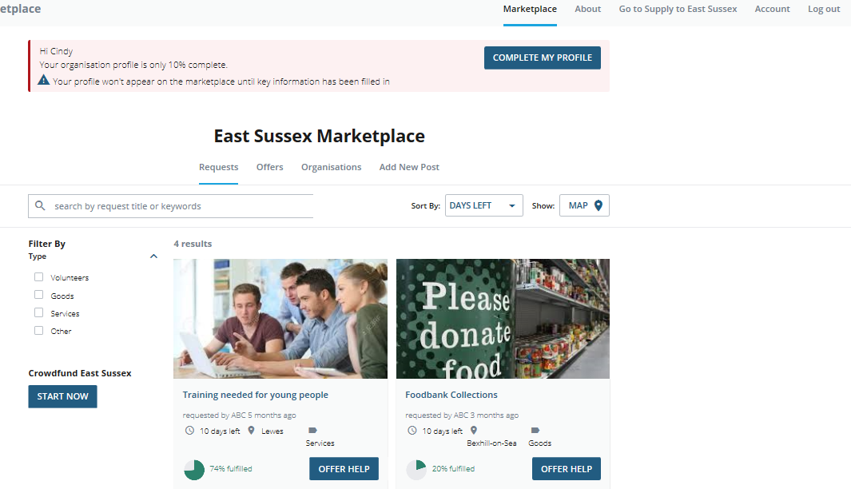

  - To access / complete your profile you can either:

- Click the “Complete My Profile” button in the message box at the top of the page below the main task bar, or

- Click “Account” on the main task bar at the top of the page, then click “Profile”

  - Enter the Key Information required. This information is required to validate your location and identify your posts.

(See picture below)
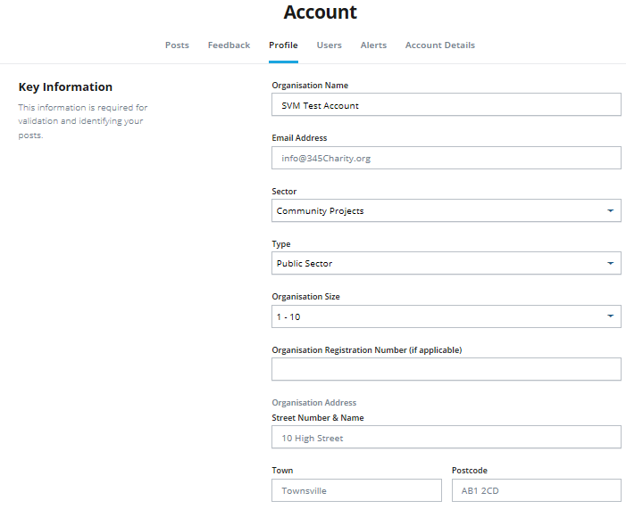

  - The “General Information” section of your profile is optional but you are strongly advised to complete this section as this information will appear on your profile page under the “Organisations” tab and at the bottom of your posts. Completing this section will enable others to learn more about your organisation and may influence whether or not other organisations choose to contact and/or work with you.

(See picture below)
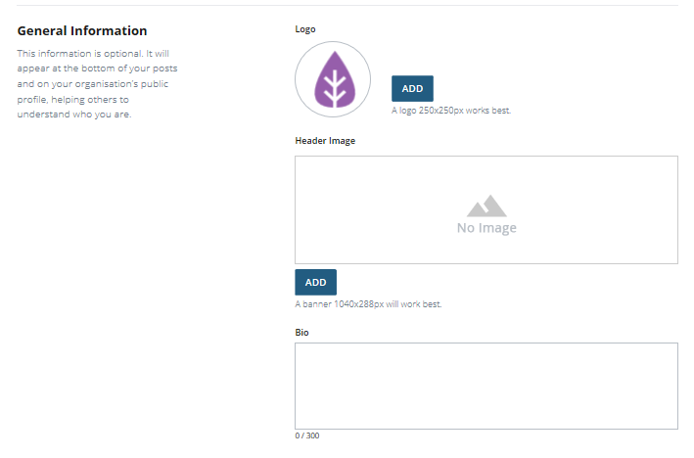
  - The “Contact Information” section is also optional. This information will appear on your profile page under the “Organisations” tab and at the bottom of your posts.
(See picture below)
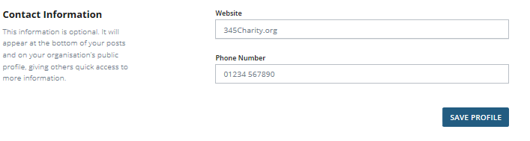

  - When you have completed your profile click “Save Profile” and you will receive confirmation that your profile has been saved.
(See picture below)
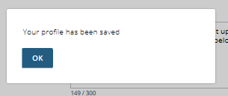
  - To view your organisation’s profile click “OK” and scroll up to the main task bar at the top of the page. Click “Marketplace” and then click “Organisations”.
(See picture below)
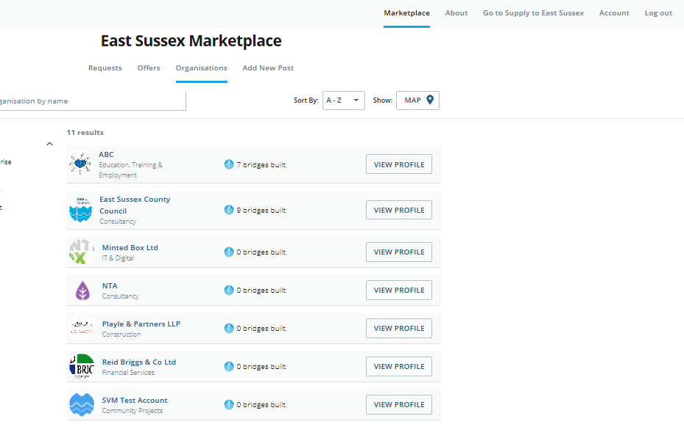
  - When you find your organisation, click “View Profile”. The information visible to others will be based on the fields you chose to complete in your organisations profile. You can change and/or update this at any time.
(See picture below)
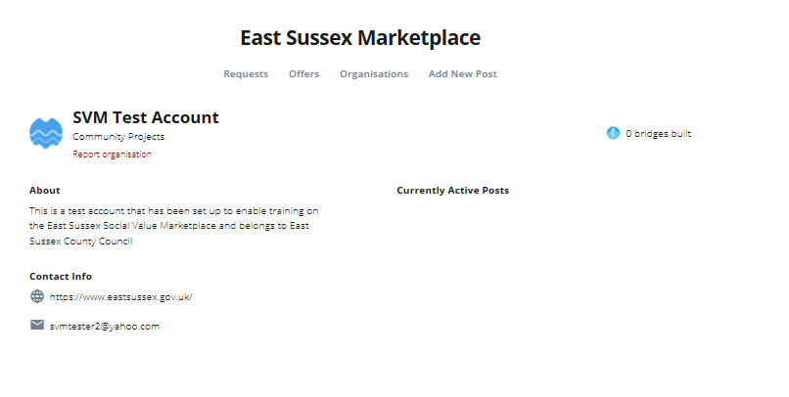
- Posting an Offer of Help and/or Post a Request for Help

  - You must be logged into your account to post an offer of help and/or post a request for help. There are two way that you can do this
- If you are on the “Marketplace” page you can click “Add New Post” or
(See picture below)
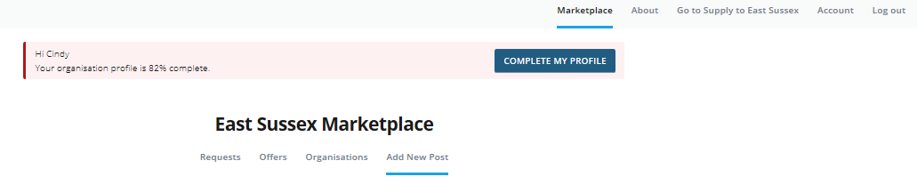

- Click “Account” on the main task bar then click “Posts” and “Add New Post”
(See picture below)
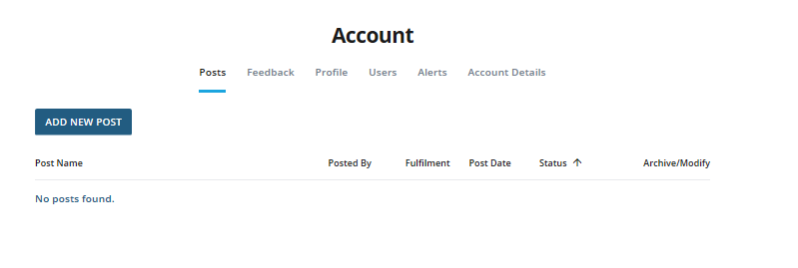

  - You must ensure you have read the “Terms of Use” and “Privacy Policy” before you add a new post as you will be required to confirm this before your offer and/or request can be submitted for approval. You can choose to post an offer or request but you cannot offer help and request help in the same post.

(See picture below)
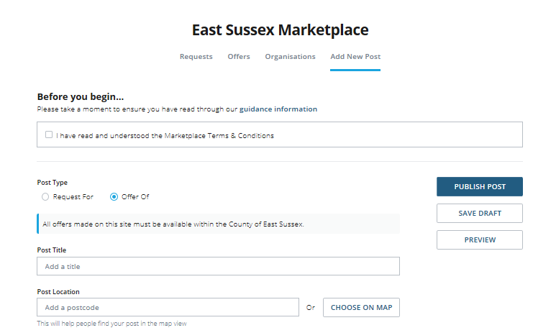

  - In the “Post Title” section you should enter the type of support you are requesting and/or the type of help you are offering. The clearer you are the easier it will be for other organisations to understand what you are requesting and/or offering. Some examples could be: Foodbank Collection; Volunteers for Sports Event; Furniture needed; Professional Legal Advice; Volunteers for Website Design; Apprenticeship Opportunities Available; Free Training Courses etc.

  - When entering the location of the offer / request please note the following:
- Requests for help will only be approved if the organisation requesting the help is based in the county of East Sussex, i.e. the postcode where help is being requested must be in the Districts/Boroughs of Eastbourne, Hastings, Lewes, Rother or Wealden.
- Offers of help can be made by any organisation based anywhere, however the offer must be delivered within the county of East Sussex i.e. the postcode where help is being offered must be in the Districts/Boroughs of Eastbourne, Hastings, Lewes, Rother or Wealden.
- Ensure you enter the exact postcode of where the help is being requested and/or where the offer is available

  - To help you better promote your offer and/or request you can upload images or add a web link / URL to a video. The use of media is optional, if you choose to use media please ensure you have read and understood our Privacy policy and have obtained explicit consent to use the media as you will be required to confirm this in order to publish your post.
(See picture below)
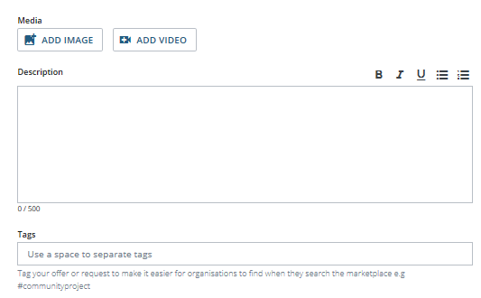

  - In the “Description” text box you should provide a summary of the request / offer. This is your opportunity to outline why other organisations should either provide you with the help you are requesting or claim the help you are offering. The more information you provide the easier it will be for other organisations to make their decision.

  - To make your post easier to find you can add tags, for example #volunteers #training. This is optional - you can still publish a post if you choose not to use tags

(See picture below)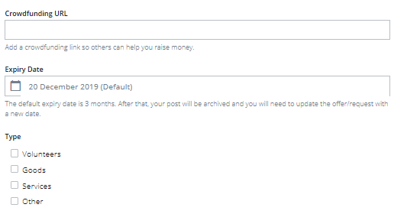

  - The ES Social Value Marketplace can only be used to request and/or offer non-financial support.
If you want to request and/or offer both financial and non-financial support you can do so by posting your offer of (or request for) financial support on Crowdfund East Sussex and insert the link to this post when requesting / offering non-financial support on the Marketplace.
This is optional so you can still publish your offer / request without a crowdfunding link.

  - To meet requests when they are needed and take advantage of help when it is available it is important to keep posts up to date. The default date for expiry on all posts is 3 months.
After this period your post will be archived into your account. You can edit the date in your account profile at any time to keep the post visible and live.

  - To help make it easier for organisations to find requests and offers you must select the “Type” of resource you are looking for

(See picture below)
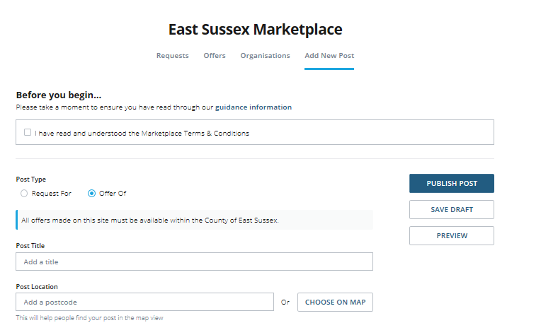

  - If you don’t have all the information you need you can click “Save Draft” and the post will be saved in your account.
  - If you have completed the information then click “Preview” to view what others will see on the Marketplace. When you are ready to make your post live click “Publish Post”
(See picture below)
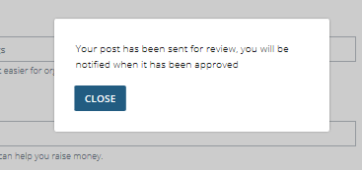

  - All posts are reviewed by the administrator before they are published on the Marketplace.

(See picture below)
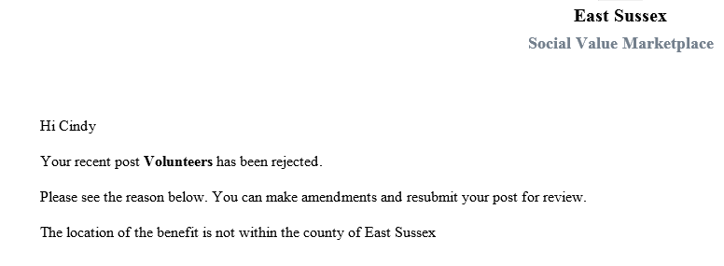

- If there is an issue with your post you will receive an email from the administrator outlining the reason why your post was not published
(See picture below)
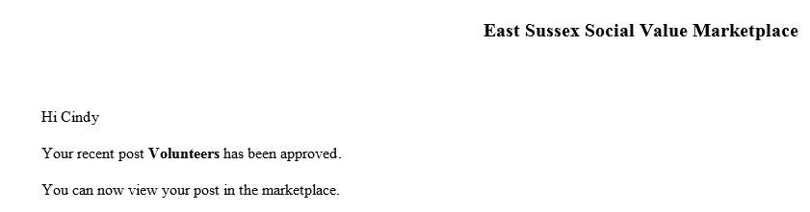

- If there are no issues with your post you will receive an email to inform you that your post has been published and is live on the Marketplace.
When your post has been published other organisations will be able to view your requests / offers and will contact you if they can help or want the resources you are offering.

  - Key points to remember:
- It is entirely up to organisations to decide who to work with
- By posting an offer or request there are no guarantees that an organisation will respond to your request or claim your offer
- The posts made by organisations can be changed at any time

- Responding to a Request for Help and/or Claiming an Offer of Help
(See picture below)
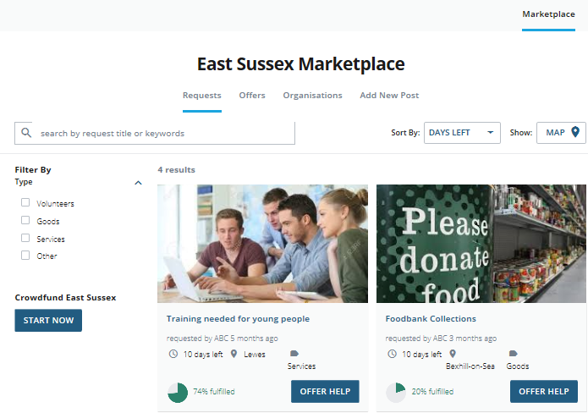

  - To view the requests or offers click “Marketplace” on the main task bar at the top of the page. Click requests / offers to view what organisations need or how organisations can help.
- You can use filters, sorting tools and map functions to specify locations, types of requests/offers and expiry dates.
- The fulfilment level indicates how much of the request has already been met, or how much of the offer has already been claimed

(See pictures below)
Click “Offer Help” to respond to a request or “Claim Offer” if you want the help available. (See picture below)
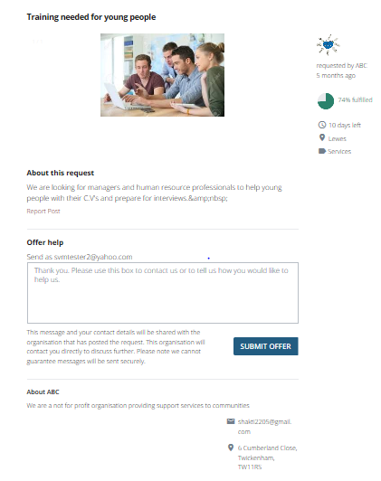

  - You are advised to review the information about the post and the organisation before you submit an offer of help or claim an offer of help.

  - To offer help or claim an offer you should use the text box provided to send an introductory message to the organisation that posted the request or offer.
- If responding to a request you should inform the organisation why you want to help and how you can help them.
- If responding to an offer you should inform the organisation why you need the help they are offering and how much of their help you need.

  - When you have completed your message click “Submit Offer” in response to a request or “Claim Offer” in response to an offer of help.
  - An email with your message will be sent to the organisation that posted the offer or request you responded to and they will contact you if they are interested in working with you.

- Giving and Receiving Feedback
  - It is a mandatory requirement for all organisations to provide feedback on the social value delivered or received through the Social Value Marketplace. Feedback will be used to ensure the continuous improvement of the Marketplace and could be used in case studies to underline the positive impact of the tool.
  - When you respond to a post and send a message to an organisation to either “Offer Help” or “Claim Offer” it is automatically logged in the “Feedback To Write” section of your account.
(See picture below)
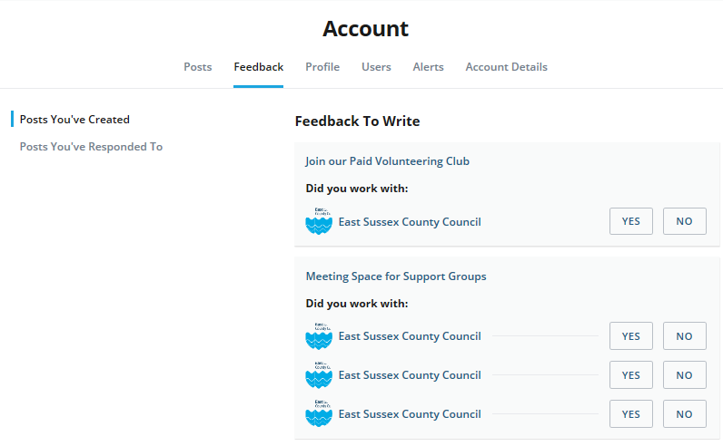

  - In the “Feedback” section you can view feedback based on
- “Posts You’ve Created” - a list of organisations that responded to your posts will automatically be created in this section
- “Posts You’ve Responded to” - a list of the organisations whose posts you responded to will automatically be created in this section

  - In both “Posts You’ve Created” and “Posts You’ve Responded to” feedback is sorted as follows
- “Feedback to Write” – In this section you need to confirm if you worked with an organisation or not.
- “Past Feedback You’ve Written” – In this section you will find information on the feedback you have already provided and shared with the organisation/s you worked with and the administrator
- “Feedback you have received” – In this section you find information on the feedback you have received from others.

  - If you select “No” this will be deleted from your profile and no further action is required by you.

  - If you select “Yes” you will be required to provide further information.
(See picture below)
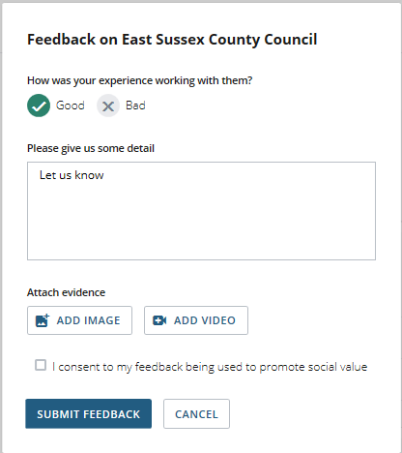

- Provide feedback on your experience with working with the organisation
- Provide details on what benefits you received or provided
- Attach an image or add a link to a video as evidence that you received or provided the benefits
- If you add an image or video link you must confirm you have explicit consent to use the media
- Tick the box to provide consent to your feedback being used to promote social value
- Click “Submit Feedback”
(See picture below)
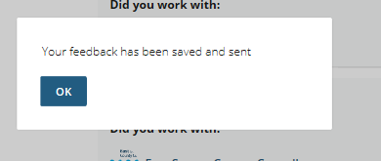

  - When you submit your feedback it will be sent to the company you worked with and the administrator of the Marketplace

  - When both you and the organisation you worked with complete the feedback then the “Bridges Built” icon on both your organisations profiles will increase by one.
(See picture below)
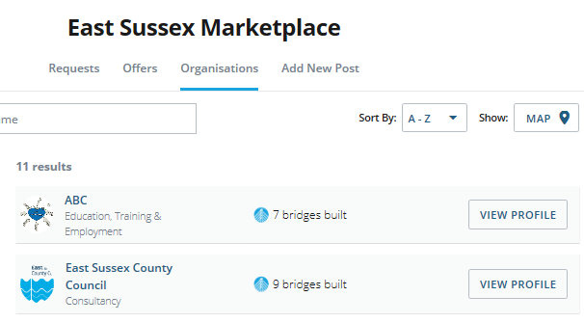

- The “About” Page
(See picture below)
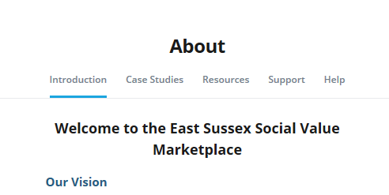

  - Click “Case Studies” to learn more about how other organisations are delivering social value

  - Click “Resources” to find useful links to information and other websites

  - Click “Support” to
- learn how to get started,
- download guidance
- get answers to frequently asked questions
- read the terms and conditions of use
- read the privacy policy

  - Click “Help”
- for quick links to information and guidance
- to access the “Contact Us” form to send a message to the administrator

- The “Account” Page

This section is only visible to you and the users attached to your account
(See picture below)
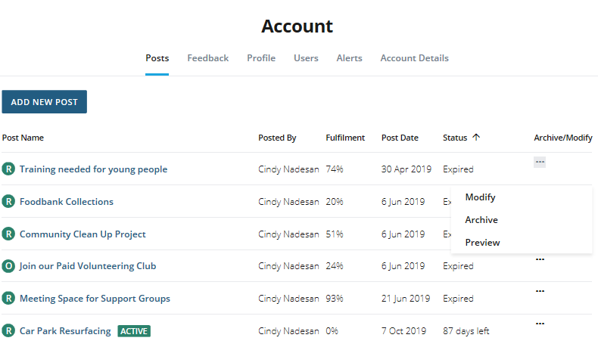

  - In the “Posts” section you will see a list of all the posts made by your organisation including those that have expired.
- Posts marked “R” are the requests your organisation has made
- Posts marked “O” are the offers your organisation has made

  - In the “Posts” section you can
- “Modify” your posts if you need to change the details.
- “Archive” your posts if the timeframe for your request / offer has ended
- “Preview” your post to see the information that will be visible to other users

  - In the “Feedback” section you can view
- Feedback to you need to write
- Past Feedback You’ve Written
- “Feedback you have received”

  - In the “Profile” section you will see the information that is visible on your organisations profile

  - In the “Users” section you will see a list of users attached to your organisations profile
(See picture below)
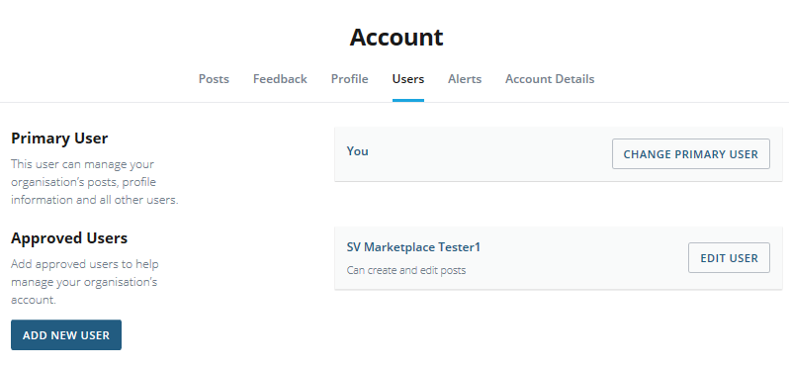

  - ‘Primary Users’ are the individuals that set up the account for the organisation. The primary user can
- Make changes to the organisations profile
- Add and respond to offers and/or requests and provide feedback
- Invite other users to join
- Controls rights of other users and enable other users to:

- add/edit posts on behalf of organisation
- edit organisations profile
- add or edit other approved users

- Make a request to the administrator to delete the organisation’s account

  - Click the “Alerts” tab to select
- Select how you would like to receive notifications - . email and/or SMS (text message). If you select SMS then you must provide a mobile number.
- What you would like to receive notifications about
- The frequency that you want to receive notifications

  - Click the “Account Details” tab to:
- View or change your contact details
- Change your password
- Delete your account
  - To delete your account:
- If you are a secondary user you can delete your account by clicking “Delete” in your account profile
- If you are the primary user and you can either:
- Transfer the ownership of the organisation’s account to a secondary user and delete your contact details
- Delete the organisation’s account
(See picture below)
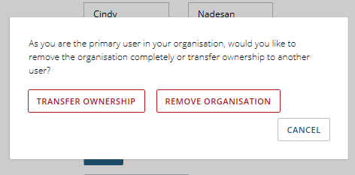

To have a profile on the Marketplace an organisation must have a primary user who accepts overall responsibility for the offers posted or commitments to fulfil requests.

- Link to Supply To East Sussex

  - Supply to East Sussex is a resource to facilitate the growth of local organisations through the development of local supply chains
(See picture below)
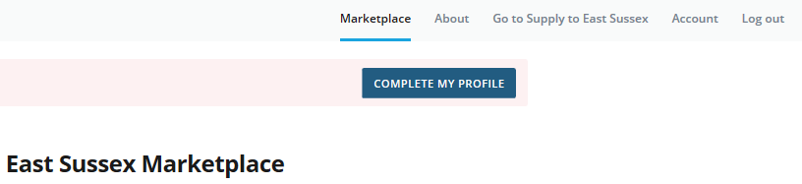

  - Local organisations can find details of local contract opportunities from a range of other organisations including Local Authorities and other public sector bodies such as Councils, Universities and Health Services on the “Opportunities” tab
  - You also have the opportunity to register on the site to promote your business and sign up for email alerts
  - The site provides information about funding and resources for workforce skills development, local grants and events.

- Link to Crowdfund East Sussex
(See picture below)

  - In 2018 East Sussex County Council launched Crowdfund East Sussex to help not-for-profit organisations get support from others who want back projects that benefit the people of East Sussex

  - Crowdfunding is a different way to raise money for good ideas. People are increasingly bypassing more traditional funding routes such as bank loans or grants and turning instead to the people around them and in their community to support their venture.

  - Crowdfund East Sussex should be used to request and offer financial support

  - The Social Value Marketplace should be used to request and offer resources e.g. volunteers, goods, services or anything other than financial support

  - You can connect to Crowdfund East Sussex by

- clicking the “Start Now” button below “Crowdfund East Sussex” on the “Marketplace” page or
- visit https://www.crowdfunder.co.uk/programmes/east-sussex

- Contact the Marketplace Administrator

  - You can contact the administrator by email:
socialvalue@eastsussex.gov.uk

  - You can use the “Contact Us” form on the “Help” tab which can be found on the “About” page

  - If you need to report a post or organisation you can
- Use the “Report Organisation” link which can be found on each organisations profile

- Use the “Report Post” link which can be found on every offer or request

