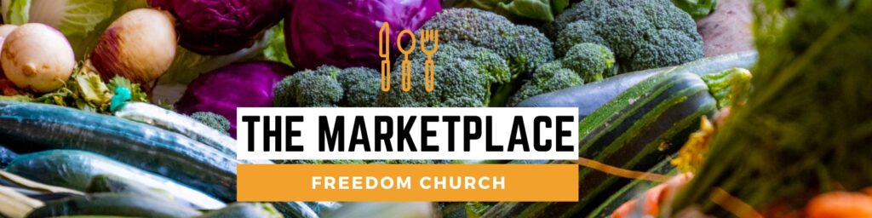

The Marketplace is a "Community Larder" which is open every Tuesday 10-11.30am at Freedom Church Sidley.
We take food donated by Tesco, which is surplus stock and out of date fresh foods which would have been sent to landfill and redistribute it to people in the local community struggling with food poverty and others who are concerned about food waste and sustainability.
We also buy food from Fareshare which are large stock items of foods which have been rejected at the markets or are now no longer part of the stock items wanted by the supermarkets, which again would have gone to waste and add them into the offering of the day. On top of this we offer people 8 items from the stock cupboard, tea, coffee, biscuits, tinned veg, soups etc which we buy in. According to the Tesco app from their donations alone since Jan 2022 we have collected 3342KG of food, equivalent to 12547 meals. Add in the food we buy each week these numbers can be doubled.
We sign people up as members and charge £2 per household to shop with us each week. People get to choose the items they want. We feel this gives people dignity, partly by paying for the food and partly by choosing what suits their families. We do not ask for referrals or proof of need. All are welcome
We have a cafe in the church which runs in tandem with The Marketplace. Members get free tea, coffee and cake - all donated- for a donation if they want to. In the cafe we have CAP (Christians against poverty) taking referrals to help people who are struggling with debt. Optivo, the local housing association has a representative coming along to talk to residents about any housing queries they may have. We have a craft corner, just for fun, a birthday table where people can get birthday cards and personalise them and being a church, we also have a "Can I pray for you " corner. Where people can ask for prayer with our volunteers. We feel we give a holistic offering to the community.
Every 6 weeks or so we have an event, clothes swap, harvest supper, local children from the primary school to "help", Christmas fairs etc, there is a cookery class starting up by a local chef "Cooking Pops " showing people basic cookery skills and offering the loan of kitchen equipment such as slow cookers and air fryers.
Approximately 45 people a week come along, some for the Marketplace and a few just for the cafe. We ran a feedback survey last month as we had our 1 year anniversary, complete with an anniversary cake, we asked for feedback and comments were made repeatedly that "We enjoy this community " " It's so lovely here " ``It's a real part of the community " "The food is so helpful ". "I always leave with a smile "
As a result of the Marketplace people now see the church as part of their community. Some are now coming to church and many people really feel the church is an important part of the area.

